https://www.youtube.com/watch?v=8kiQ6lKgl3E
http://www.lkdsb.net/Students/besafe.htm
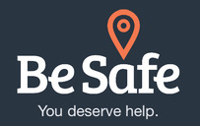

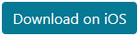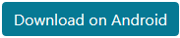

Be Safe is meant to help you make decisions in a crisis. It will:
- allow you to make a safety plan
- inform you about resources in London, Ontario and surrounding area
- give you options for getting help
- empower you to reach out safely
Check out the How to Use Be Safe and print your own Personal Safety Plan in the Be Safe Pocket Guide - Chatham Kent or Be Safe Pocket Guide - Sarnia Lambton. View our training webinar on using the app in your practice.

Be Safe was created by a dedicated team of youth, mindyourmind, the Centre for Addiction and Mental Health, and other partners in the Systems Improvement through Service Collaboratives initiative in London, Ontario and surrounding area to improve access to and coordination of mental health and addictions services for children, youth and families.
Learn more about the development process in this article from EENet or this post on the CAMH website.

It is now available in thirteen regions: Brant, Chapleau, Chatham-Kent, Durham, Great Sudbury, Haldimand-Norfolk, Hastings-Prince Edwards, Hamilton, London Middlesex, Manitoulin Island, Sarnia Lambton, Waterloo Wellington and Windsor Essex County, as well as Ontario-wide.

Page last updated:

